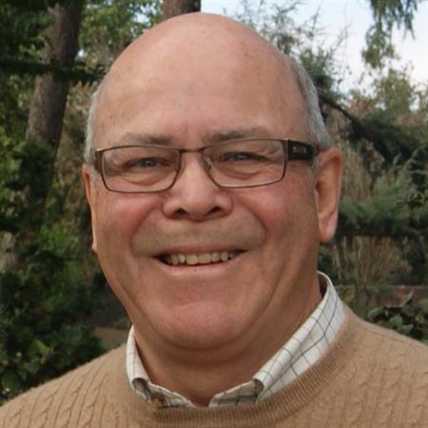
Posted by Mike Weaver, District 5240 Scholarship Advisor

Rotary Invests in the Future

Are you aware that Rotary, on average, gives $7.5 million in scholarships are given out each year? In using funds in this way, The Rotary Foundation and Rotary Clubs support future leaders and humanitarians by funding scholarships for undergraduate and graduate study. Let me tell you what happened to me very recently.

Twenty-five years ago, while living in Africa, I was a member of the Rotary Club of Gaborone, Botswana. This past June I saw an appeal on the Internet from my former club that asked to help a young doctor complete her advanced studies to qualify as a surgeon in Botswana. A little research revealed a letter from the Botswana Society of Surgeons that said there were only 10 certified surgeons in the entire country and six of those were in private practice. That leaves four surgeons to serve the serious medical needs of 1.8 million people who have to rely on the government run health services.

I contacted Bill McLellan, Past President of the Gaborone club, and said that I was interested in assisting if I could. He introduced me to Michael Dillard who is a Rotarian in Bend, OR and also wanted to help. Bill refers to us as Mike1 and Mike2.

The doctor, Weludo Ngwisanyi, had been self-funding her training for the last three years but needed $30,000 to complete the five-year program to become a certified surgeon. Her plan is to work in the public health hospitals and also train new medical technicians to expand the coverage of care to the disadvantaged population in the country.

A global grant was the only answer and I decided to write one. The three of us started raising $10,000 cash in order to qualify for $10,000 in DDF from three Rotary districts in Botswana, Oregon and California. That allowed us to request $10,000 from TRF World Fund.

We submitted the grant on December 17, 2020 in time to for review and approval before Weludo starts her next semester. TRF approved our global grant on January 4th of this year.

Any Rotary club can apply to The Rotary Foundation for a global scholarship grant. The application process for these global grants has a few special requirements however. Eligible students have to have been accepted at a qualified university aboard for graduate study in one of Rotary’s six focused causes:
- Promoting peace
- Fighting disease
- Providing clean water, sanitation, and hygiene
- Saving mothers and children
- Supporting education
- Growing local economies
Scholarships last from one to four years and can include an entire degree program. Global grant scholarships are funded using cash contributions plus DDF matched by the World Fund.

Each year, TRF also selects up to 130 professionals from around the world to receive fellowships to study at one of six Rotary Peace Centers. Through academic training, practice, and global networking opportunities, the Rotary Peace Fellow program develops leaders who become career peace builders in their communities and around the world. These fellowships cover tuition and fees, room and board, round-trip transportation, and all internship and field study expenses.

Many District 5240 clubs are very active in supporting the students in their community by awarding scholarships to local high school seniors. As just one example, the Rotary Club of Ojai Educational Foundation annually awards scholarships of over $120,000 to twenty-seven deserving graduates each year from as many as eight high schools serving the Ojai Valley. In the past 25 years, over a million dollars in scholarships have been awarded to 450 students.

Rotary clubs that don’t have a foundation can use their District Designated Funds (DDF) prepare a district grant to fund scholarships for secondary, undergraduate, or graduate study. District grants can be used for students studying any subject either locally or overseas. The scholarship may cover any length of time, from a six-weeks language training program to a year or more of university study. Rotary scholarships are open to anyone except Rotary members and their families.

Rotary is an amazing organization that allows us to accomplish things that seem impossible for one person. You may not always be able to be on the frontlines to participate directly in the amazing projects that Rotary clubs are doing every day at home and throughout the world. But your giving to The Rotary Foundation Annual Fund will allow this great work of “helping others” to continue and you can feel proud to say, “I’m a Rotarian”.

